# Model-Based Individualization of Colistin Dosing in Critically Ill Patients Using Population PK Modeling

## Introduction

Colistin is often used as a last-resort antibiotic for multidrug-resistant Gram-negative infections, particularly in critically ill ICU patients. However, its therapeutic window is narrow, and its pharmacokinetics (PK) is complex, especially in the presence of variable renal function and renal replacement therapy (RRT). Therefore, optimizing dosing through Population Pharmacokinetic (PopPK) modeling is critical to improve efficacy (achieving PK/PD targets like AUC/MIC ≥ 60) while minimizing toxicity.

## Aim and Objectives

Primary Aim:  
- Develop a PopPK model for colistin and its prodrug colistin methanesulfonate (CMS) in critically ill ICU patients.  
- Use the model to simulate individualized dosing strategies to achieve therapeutic PK/PD targets.  
- Address the impact of renal function (CrCL), RRT, age, and weight on colistin pharmacokinetics.

Secondary Aim:  
- Identify and quantify the influence of covariates on PK parameters.  
- Recommend optimized, personalized dosing regimens for different patient subgroups.

## Methodology

Step 1: Data Preparation  
- Dataset: parent_metabolite_data.csv  
- Variables: CMS and colistin plasma concentrations, covariates (age, CrCL, weight, MIC, RRT status).  
- Censored data handling: Standard Monolix practices.

Step 2: Base Structural Model Development  
- Parent-metabolite model structure.  
- Two-compartment model linked by transformation kinetics.

Step 3: Model Estimation  
- Software: Monolix (Run: parent_metabolite_project.mlxtran)  
- Algorithm: SAEM  
- Convergence achieved successfully.

Key Parameter Estimates:  
ka_pop: 0.181 (RSE: 2.5%, Shrinkage: 13.2%)  
V_pop: 10.834 (RSE: 2.5%, Shrinkage: 8.9%)  
k_pop: 0.118 (RSE: 4.0%, Shrinkage: 51.9%)  
...

Step 4: Covariate Model Building  
- Automatic covariate search (COSSAC, SCM)  
- Significant covariates: CrCL, RRT, Weight, Age.

Step 5: Final Model Evaluation  
- Goodness-of-fit plots  
- Individual fits  
- Residual diagnostics  
- Visual Predictive Checks (VPC)

Step 6: Bootstrap and Precision Analysis  
- Planned: ≥200 bootstrap replicates.

Step 7: Model-Based Simulations  
- PTA for AUC/MIC ≥ 60.  
- Impact of CrCL and RRT on target attainment.

Step 8: Dose Optimization  
- Personalized dosing recommendations based on simulations.

## Results Summary

Key Findings:  
- CMS PK is significantly impacted by renal function (CrCL).  
- High shrinkage seen for inter-compartmental transfer parameters.  
- Combined error model adequately describes the residual variability.  
- Standard dosing may underdose patients with augmented renal clearance.

## Limitations

- Sample size and covariate diversity limitations.  
- Moderate-to-high shrinkage in some parameters.  
- No external validation performed yet.

## Conclusion

The developed PopPK model for CMS and colistin demonstrates good stability and predictive performance. Renal function significantly affects drug exposure, highlighting the necessity for individualized dosing in ICU patients. Final model-based simulations and bootstrap validations will further refine dosing recommendations.

## Next Steps

- Final covariate model confirmation.  
- Bootstrap (≥200 runs) for precision analysis.  
- Simulation studies under clinical scenarios.  
- Dosing recommendation tables and manuscript preparation.

**Report**

Tables

Table 1: Estimated population parameters

|  |  |  |  |  |  |  |  |
| --- | --- | --- | --- | --- | --- | --- | --- |
| Parameter | Value | | Stoch. Approx. | | | | Cond. Mode |
| S.E. | R.S.E.(%) | P2.5 | P97.5 | Shrinkage (%) |
| **Fixed Effects** | | | | | | | |
| ka_pop | 0.181 | | 0.00456 | 2.521 | 0.172 | 0.19 | 13.194 |
| V_pop | 10.834 | | 0.268 | 2.475 | 10.321 | 11.372 | 8.896 |
| k_pop | 0.118 | | 0.00479 | 4.046 | 0.109 | 0.128 | 51.921 |
| k12_pop | 0.0434 | | 0.00102 | 2.339 | 0.0415 | 0.0455 | 48.671 |
| k21_pop | 0.0465 | | 0.00162 | 3.485 | 0.0434 | 0.0498 | 63.578 |
| km_pop | 0.0303 | | 0.000409 | 1.349 | 0.0295 | 0.0312 | 8.925 |
| Kpm_pop | 0.102 | | 0.000893 | 0.875 | 0.1 | 0.104 | 66.121 |
| **Standard Deviation of the Random Effects** | | | | | | | |
|  | Value | C.V.(%) |  | | | | |
| omega_ka | 0.0975 | 9.771 | 0.0115 | 11.823 | 0.0775 | 0.123 |  |
| omega_V | 0.0976 | 9.787 | 0.0103 | 10.558 | 0.0795 | 0.12 |  |
| omega_k | 0.0779 | 7.803 | 0.0167 | 21.497 | 0.0518 | 0.117 |  |
| omega_k12 | 0.0909 | 9.108 | 0.0441 | 48.515 | 0.0396 | 0.209 |  |
| omega_k21 | 0.0834 | 8.355 | 0.0299 | 35.848 | 0.0437 | 0.159 |  |
| omega_km | 0.104 | 10.432 | 0.0107 | 10.276 | 0.0852 | 0.127 |  |
| omega_Kpm | 0.0268 | 2.678 | 0.0379 | 141.402 | 0.00524 | 0.137 |  |
| **Error Model Parameters** | | | | | | | |
| a1_Cp | 0.0929 | | 0.00493 | 5.303 | 0.0838 | 0.103 |  |
| b1_Cp | 0.101 | | 0.00369 | 3.649 | 0.0941 | 0.109 |  |
| a2_Cm | 0.097 | | 0.0133 | 13.69 | 0.0745 | 0.126 |  |
| b2_Cm | 0.194 | | 0.00515 | 2.649 | 0.184 | 0.205 |  |

Table 2: Log-likelihood and Information criteria

|  |  |
| --- | --- |
| CRITERIA | IMPORTANCE SAMPLING |
| -2 x log-likelihood (OFV) | 8408.1 |
| Akaike Information Criteria (AIC) | 8444.1 |
| Bayesian Information Criteria (BIC) | 8487 |
| Corrected Bayesian Information Criteria (BICc) | 8525.8 |

Plots

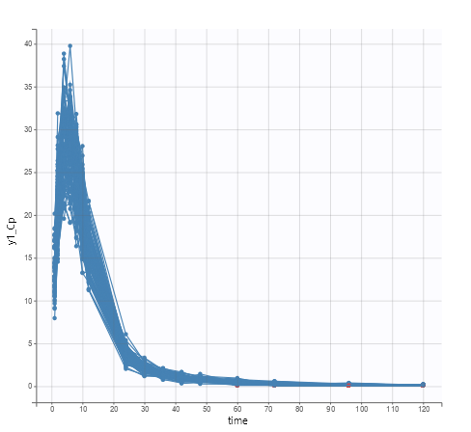

Figure 1: Observed data

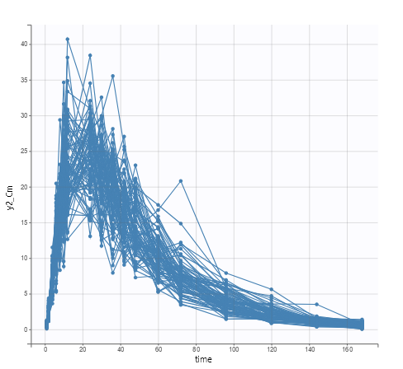

Figure 2: Observed data

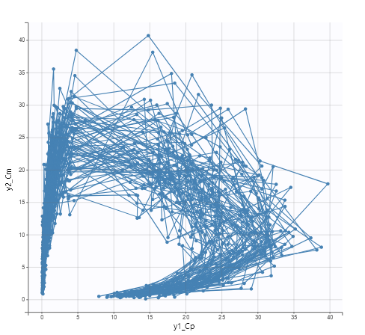

Figure 3: Bivariate data viewer

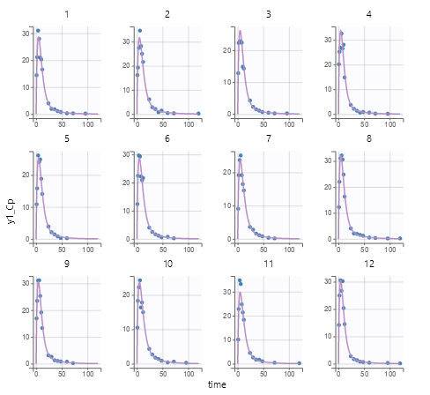













Figure 4: Individual fits

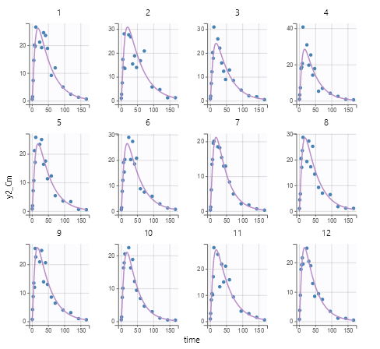

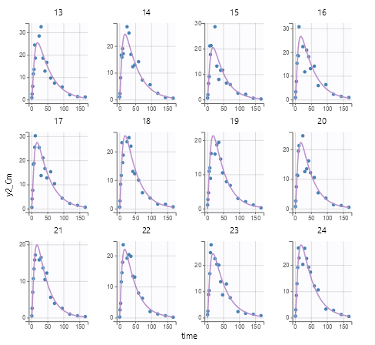

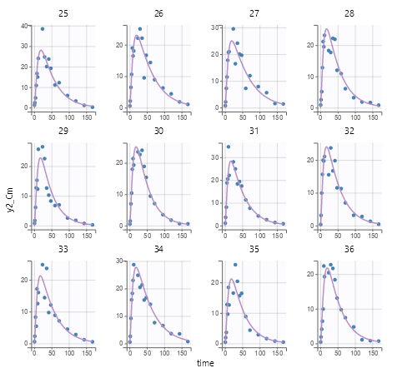

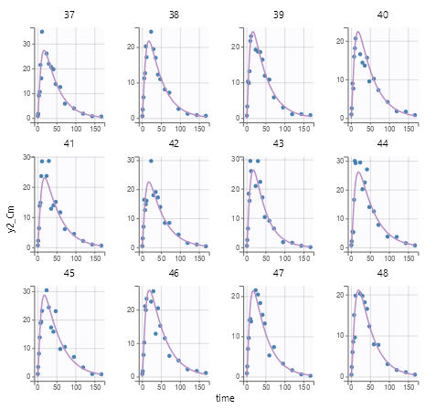

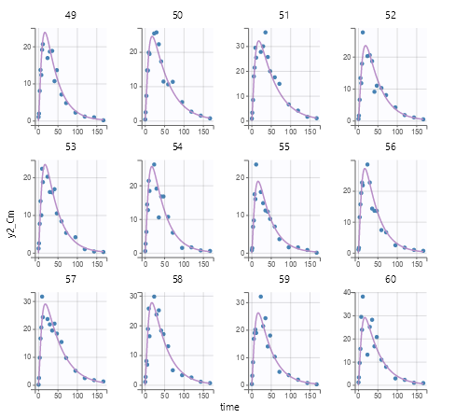

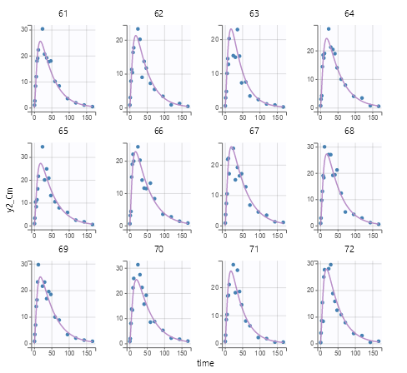

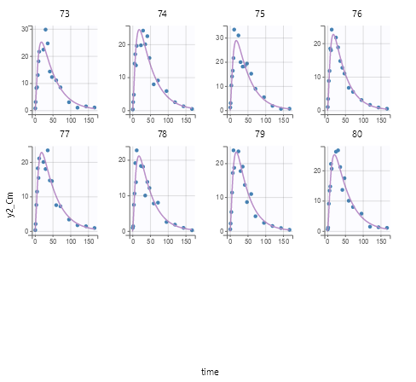

Figure 5: Individual fits

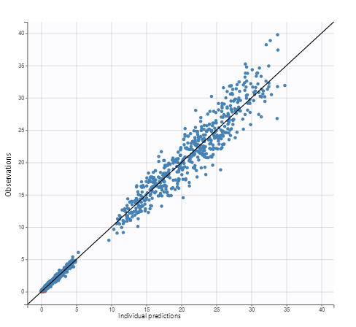

Figure 6: Observations vs predictions

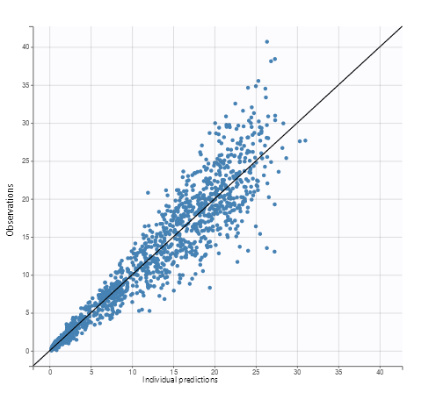

Figure 7: Observations vs predictions

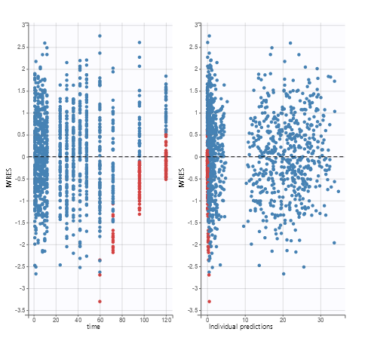

Figure 8: Scatter plot of the residuals

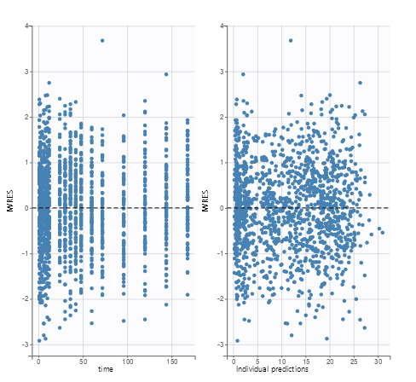

Figure 9: Scatter plot of the residuals

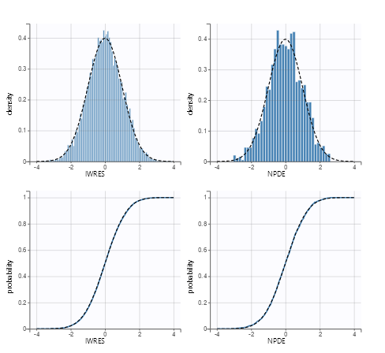

Figure 10: Distribution of the residuals

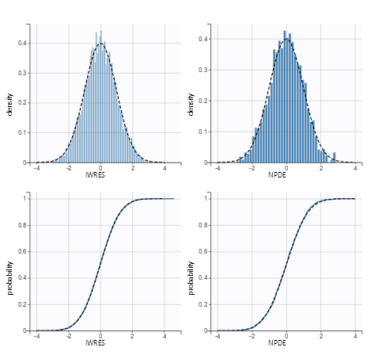

Figure 11: Distribution of the residuals

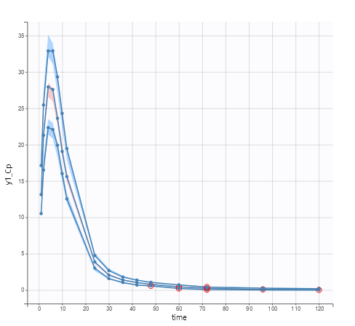

Figure 12: Visual predictive check

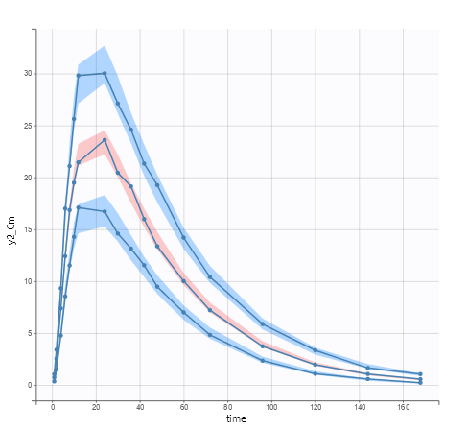

Figure 13: Visual predictive check

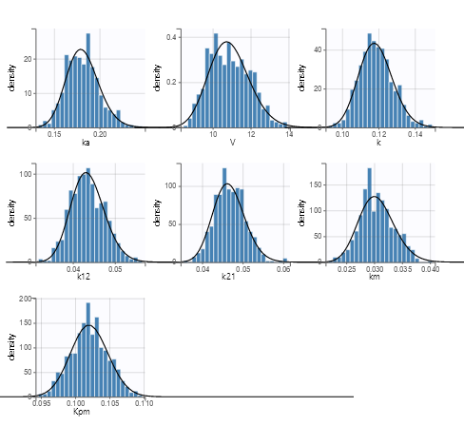

Figure 14: Distribution of the individual parameters

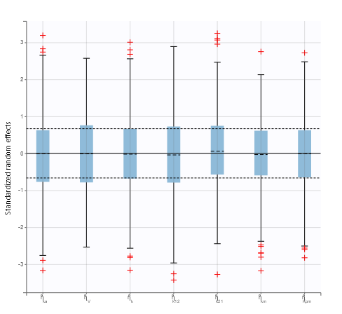

Figure 15: Distribution of the standardized random effects

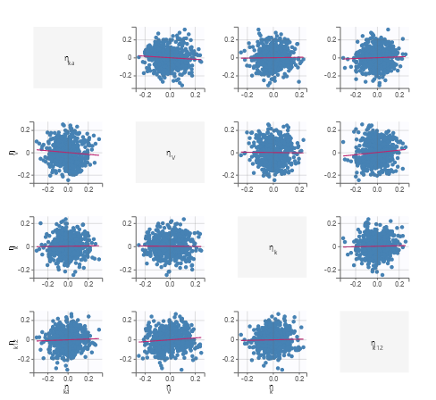

Figure 16: Correlation between random effects

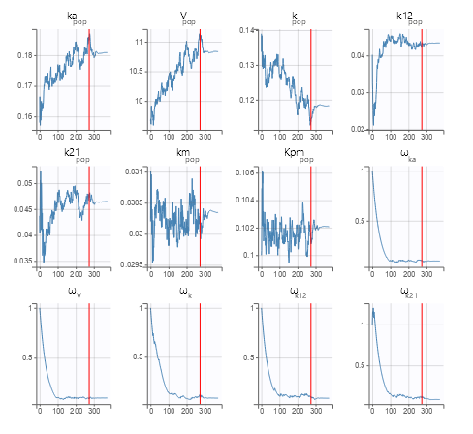

Figure 17: SAEM